DATAFRAMES IN PYSPARK
Agenda
- Introduction
- Characterisitics
- Advantages
- Difference between RDD and Dataframes
- Schemas
- Types of Schema
- Ways to create Dataframe
- PySpark Operations
  - show()
  - StructType & Struct Field
  - PySpark Column Class Functions
Introduction:
A DataFrame in PySpark is a distributed collection of data organized into rows and columns, similar to a table in a relational database or a DataFrame in pandas. It is a higher-level abstraction built on top of RDDs (Resilient Distributed Datasets) to make working with structured data easier and more efficient.
Key Characteristics:
- Structured Format: DataFrames store data in a tabular format with named columns and defined data types.
- Distributed and Scalable: DataFrames are distributed across a cluster, making them suitable for processing large datasets.
- Optimized Execution: Built-in optimizations like Catalyst optimizer ensure efficient execution of transformations and queries.
- Integration with SQL: DataFrames can interact seamlessly with SQL queries for structured data analysis.
Use Cases:
- Big Data Processing: Handling large volumes of structured or semi-structured data.
- Data Cleaning: Filtering, aggregating, and transforming data efficiently.
- Data Integration: Joining datasets from multiple sources like databases and files.
- Analytics: Performing group-wise aggregations, statistics, and pivoting.
- Data Export: Writing processed data into formats like CSV, JSON, or Parquet for downstream use.
Advantages of DataFrames:
- Ease of Use: High-level API and SQL-like syntax make DataFrames easier to use compared to RDDs.
- Performance: Catalyst optimizer and Tungsten execution engine enable faster query execution and memory usage.
- Interoperability: Seamless integration with SQL and other Spark components.
- Scalability: Distributed nature allows processing of massive datasets across clusters.
- Rich API: Includes a wide range of operations like filtering, grouping, and joining.
- Fault Tolerance: Inherits fault tolerance from RDDs, ensuring reliable computation in distributed environments.
Differences between RDD and Dataframe in Pyspark:
- RDD (Resilient Distributed Dataset) is a low-level abstraction in Spark for working with distributed data. It represents a collection of objects spread across a cluster.
DataFrame is a higher-level abstraction designed for structured data. It organizes data into rows and columns, similar to a table in a relational database.
- RDDs do not have a schema, so the data structure is not strictly defined. Each element is treated as a generic object.
DataFrames have a schema, which specifies column names and their corresponding data types.
- Working with RDDs often requires writing functional code (using map, filter, etc.), which can be verbose and harder to debug.
DataFrames provide a high-level API, making it easier to perform operations like filtering, grouping, and aggregation with SQL-like syntax.
- RDDs lack built-in optimizations, so performance tuning must be handled manually.
DataFrames are optimized using Spark's Catalyst optimizer and Tungsten execution engine, resulting in better performance for many operations.
- RDDs use Java or Python object serialization, which can lead to higher memory usage. DataFrames utilize optimized serialization formats (like Tungsten), improving memory efficiency and execution speed.
- Debugging is harder with RDDs because the data is unstructured, and errors are not tied to specific fields or columns.
DataFrames offer better error messages and debugging capabilities because of their schema.
- RDDs do not integrate directly with SQL operations.
DataFrames can be queried using Spark SQL, making them ideal for analysts familiar with SQL.
- RDDs are suited for low-level transformations and computations on unstructured or semi-structured data.
DataFrames are best for structured or semi-structured data where schema and SQL-like operations are beneficial.
- RDD operations are executed as-is, without query optimization.
DataFrame operations are optimized before execution, leveraging query planning and execution strategies.
Schema
A schema in PySpark defines the structure of a DataFrame. It specifies the column names and their corresponding data types, as well as whether a column allows null values. Schemas are crucial when working with structured data as they enforce consistency and enable optimized execution.
Importance of Schema
- Provides a clear structure to the data.
- Ensures data type validation during processing.
- Enables PySpark's optimizations like Catalyst for better performance.
- Facilitates error debugging by identifying data mismatches.
Key Components of a Schema in PySpark
- StructType: Represents the overall schema, containing multiple fields.
- StructField: Represents an individual column with a name, data type, and nullability.
- Data Types: Includes common data types like StringType, IntegerType, DoubleType, and complex types like ArrayType and MapType.
Types of Schema in PySpark
1. Explicit Schema
- The schema is manually defined by the user using StructType and StructField.
- This method is used when you know the exact structure of the data beforehand.
- Use Case: When importing structured data or ensuring data consistency.

Example:
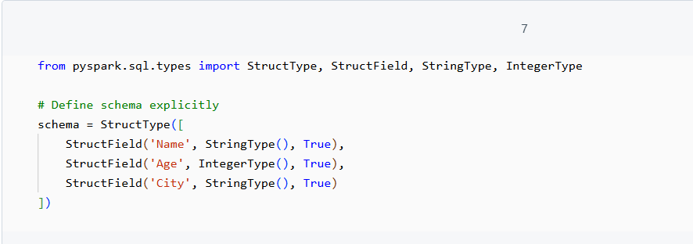

2. Inferred Schema
- The schema is automatically inferred by PySpark based on the data.
- Commonly used when reading data from files like CSV, JSON, or Parquet.
- Use Case: When working with semi-structured data where you do not want to define a schema manually.
NOTE: It's just like uploading data that we also did in RDD which includes first uploading data to dbfs then pastin ght elink from there.
Example:
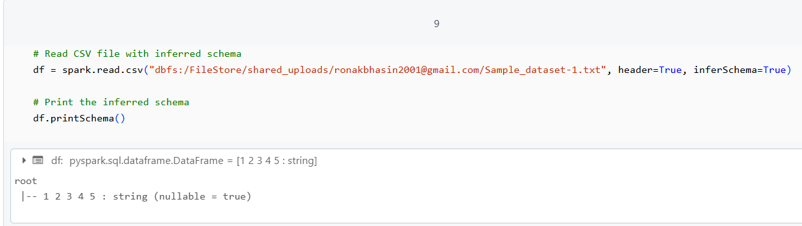
3. Dynamic Schema
- The schema is dynamically modified at runtime based on data or requirements.
- This is achieved through programmatic updates to the schema.
- Use Case: When dealing with unknown or frequently changing data formats.

Example:
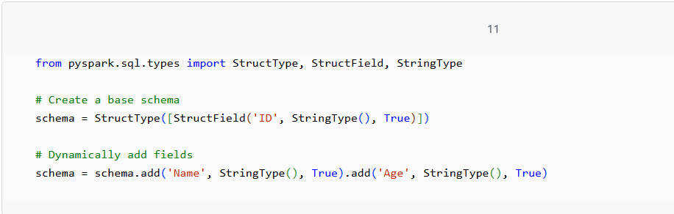

Ways to create Dataframe
1. Create Empty DataFrame with Schema (Using RDD and StructType)
Steps:
- Define an empty RDD using the Spark context.
- Create a schema using StructType and StructField to specify column names and data types.
- Pass the empty RDD and schema to the createDataFrame() method of SparkSession.
Example:
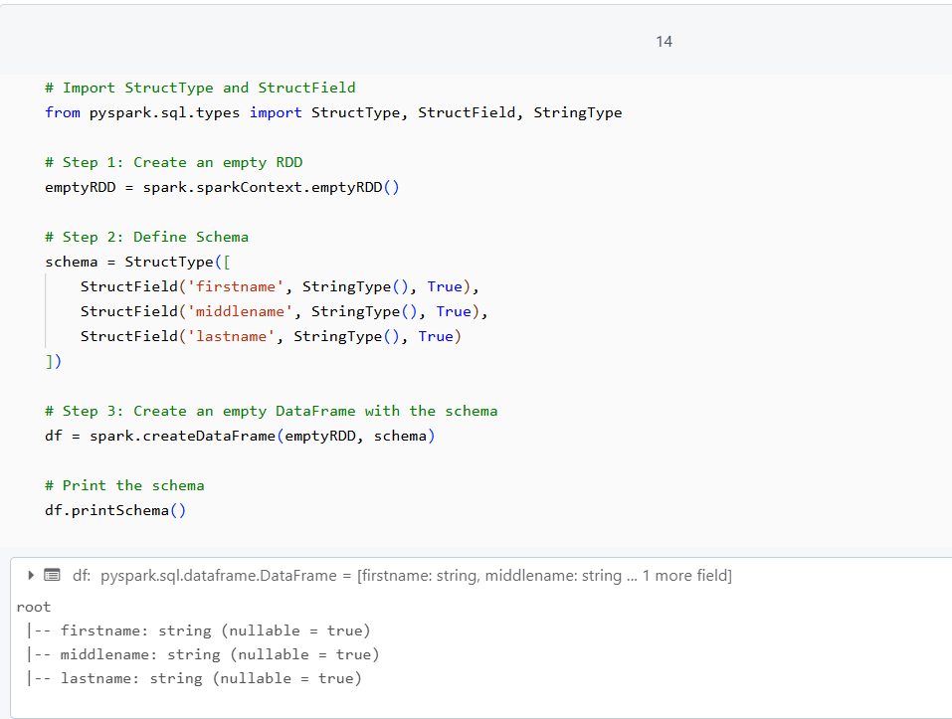
2. Convert Empty RDD to DataFrame Using toDF()
Steps:
- Create an empty RDD.
- Use the toDF() method to directly convert the RDD into a DataFrame with the defined schema.
Example:
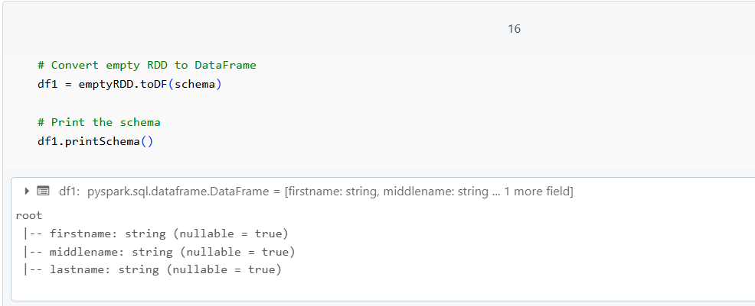

3. Create Empty DataFrame Directly with Schema (Without RDD)
Steps:
- Skip creating an empty RDD.
- Use createDataFrame() directly with an empty list [] and the schema.
Example:
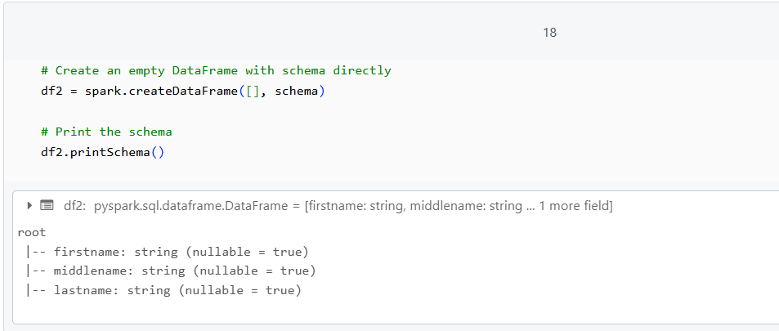

4. Create Empty DataFrame Without Schema (No Columns)
Steps:
- Define an empty schema using StructType([]).
- Use createDataFrame() with an empty list [] and the empty schema.
Example:
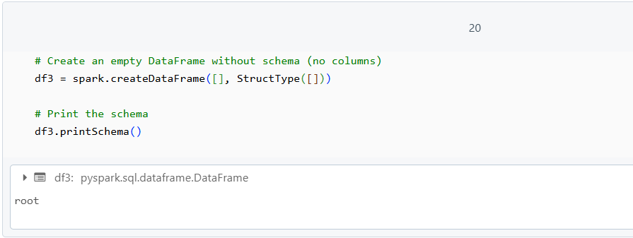

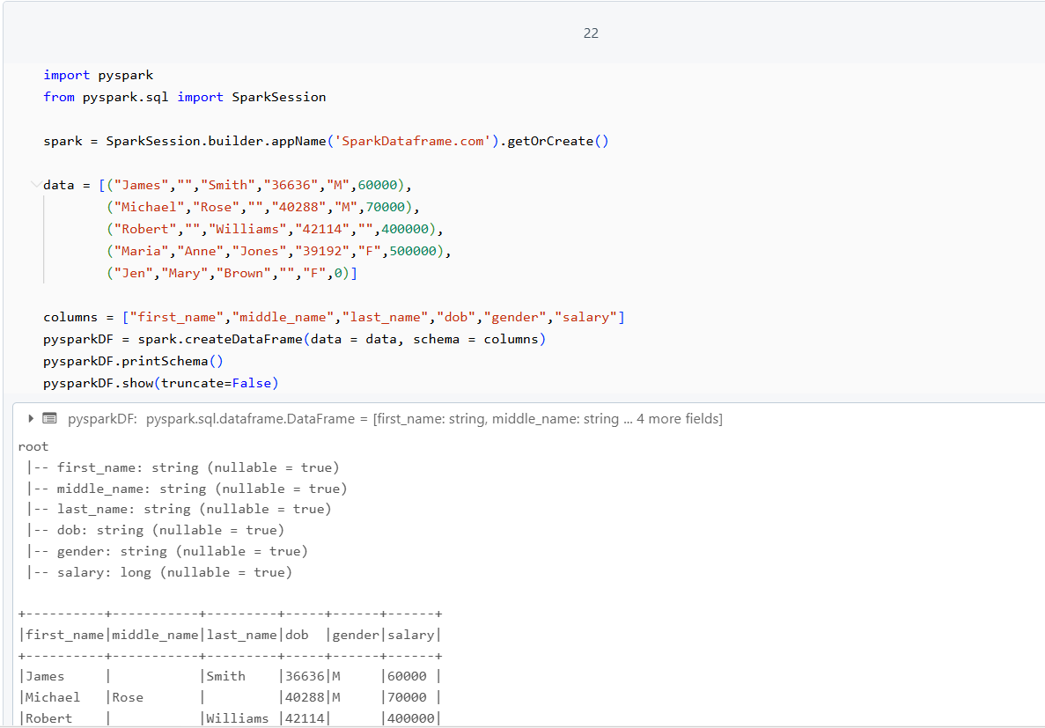

PySpark Operations
1.show()
The show() method in PySpark is used to display the contents of a DataFrame. Here are some examples:
Example 1:
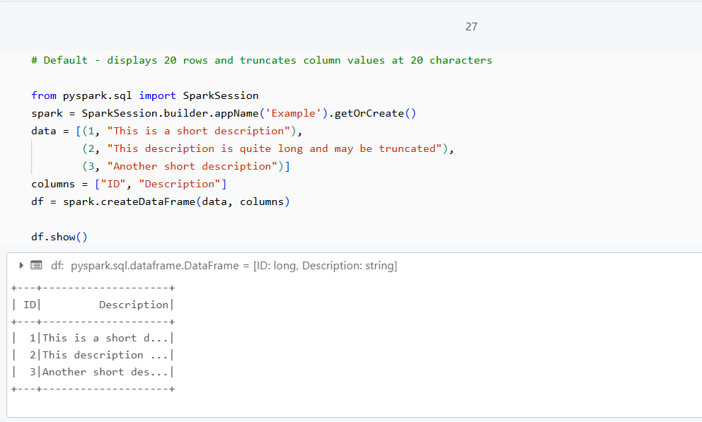

Example 2: Display Full Column Contents
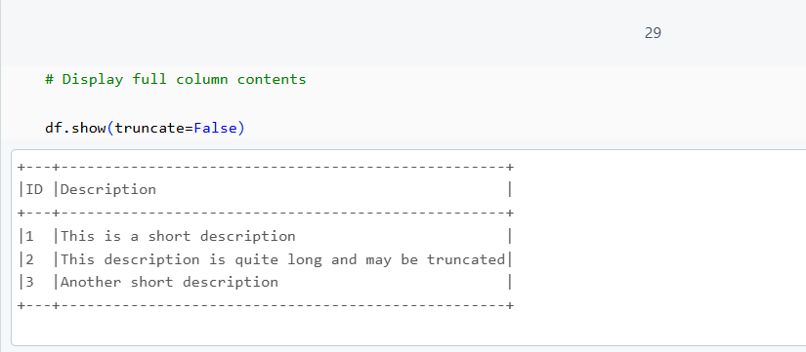

Example 3: Limit Rows and Show Full Column Contents
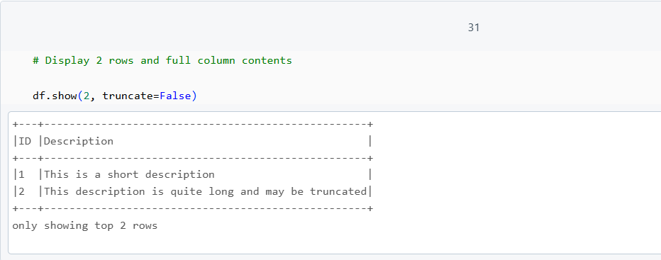

Example 4: Truncate Column Values at Specific Length
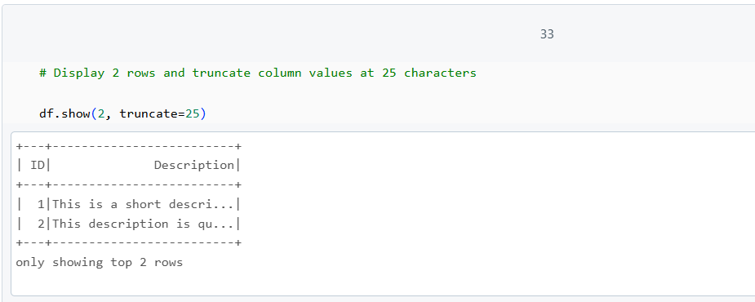

Example 5: Display Vertically
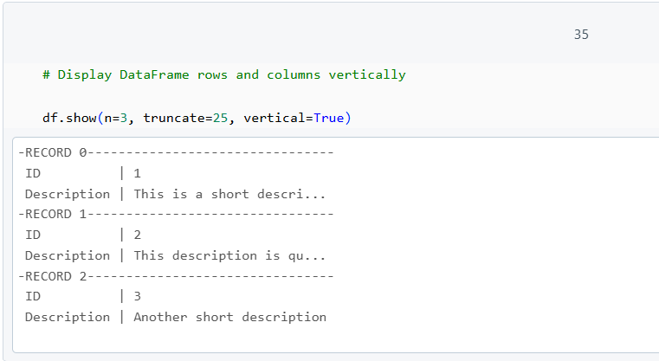
2. StructType & Struct Field
- StructType
Defines the schema (structure) of a PySpark DataFrame.
Example:
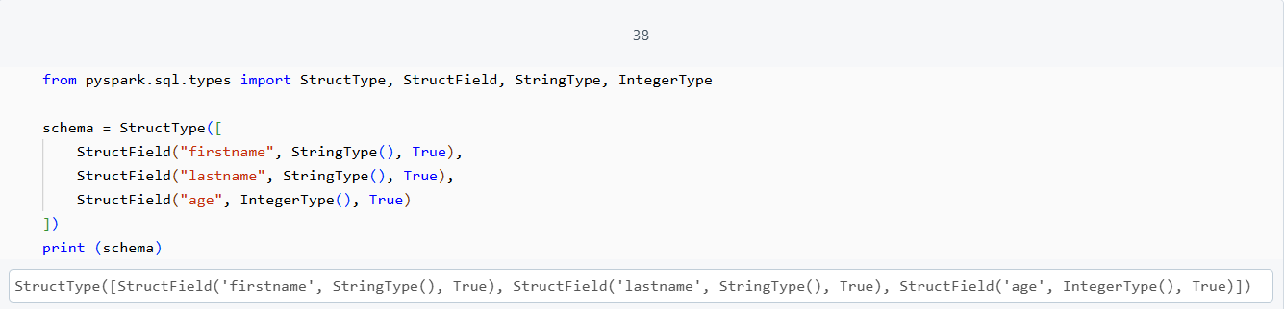
- StructField
Represents individual fields in the schema.
Example:
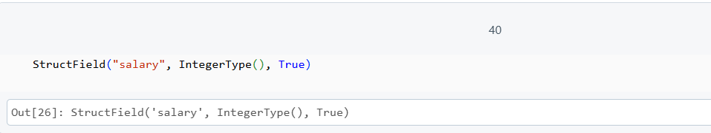

- Creating a DataFrame with Custom Schema
Example:
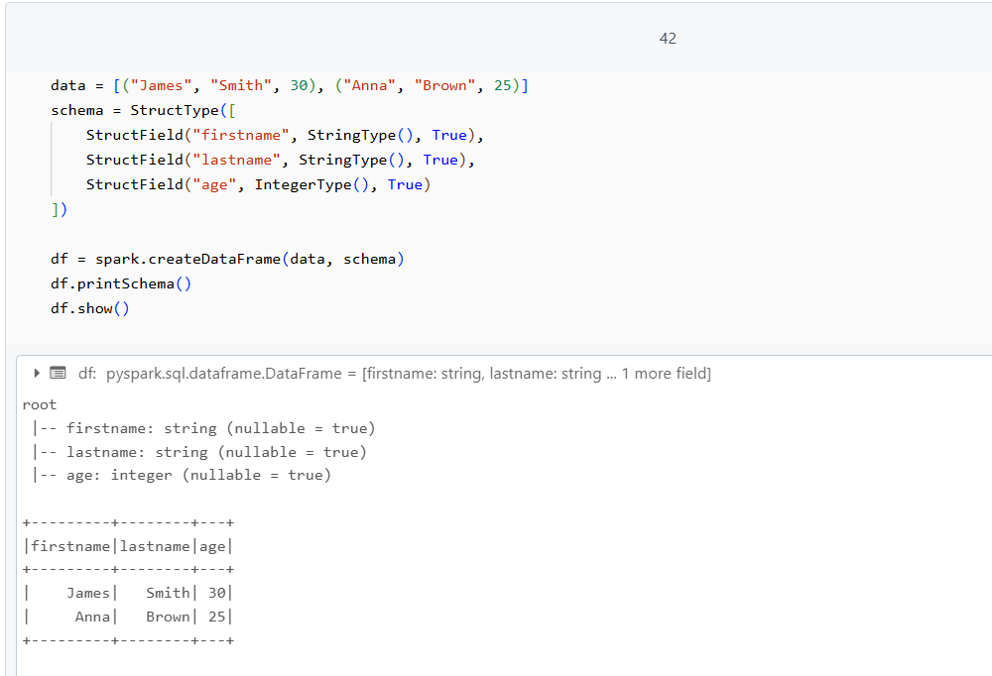
- ArrayType and MapType with StructType
- ArrayType: Represents arrays of elements.
- MapType: Represents key-value pairs.
Example:
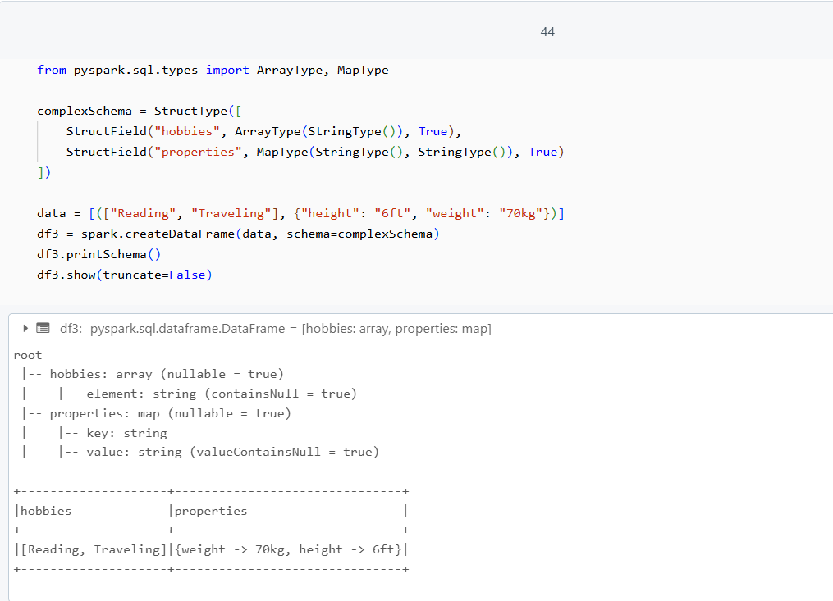

3. PySpark Column Class
The PySpark Column class represents a DataFrame column, providing a range of functions for column operations like arithmetic, filtering, aliasing, and handling nested structures. It’s vital for manipulating and transforming DataFrame columns effectively.
A.Create Column Class Object
Columns can be created using the lit() function, col() function, or accessed directly from DataFrame objects. These methods allow both simple and complex column manipulations.
- lit() Function
The lit() function in PySpark is used to create a column with a constant value. This can be useful when you want to add a new column with a constant value to a DataFrame or when you want to perform operations involving constant values.
- Selecting Columns with df[column_name] and df.column_name
PySpark provides multiple ways to select columns from a DataFrame:
- Using df[column_name] (Square Brackets):
This is one way to access columns in a DataFrame.
- Using df.column_name (Dot Notation):
You can also access columns using dot notation, which is more concise.
- Accessing Column Names with Backticks (Dot Notation for Special Characters)
When column names contain special characters (such as a dot .), you need to escape the column name using backticks (`).
- Using col() Function
The col() function in PySpark is another way to reference columns. It is useful when performing more complex operations, such as transformations and expressions.
- Working with Struct Columns
In PySpark, a StructType is used to define a column that contains a structure or nested data, which can hold multiple fields of different data types. You can access these nested fields by using dot notation.
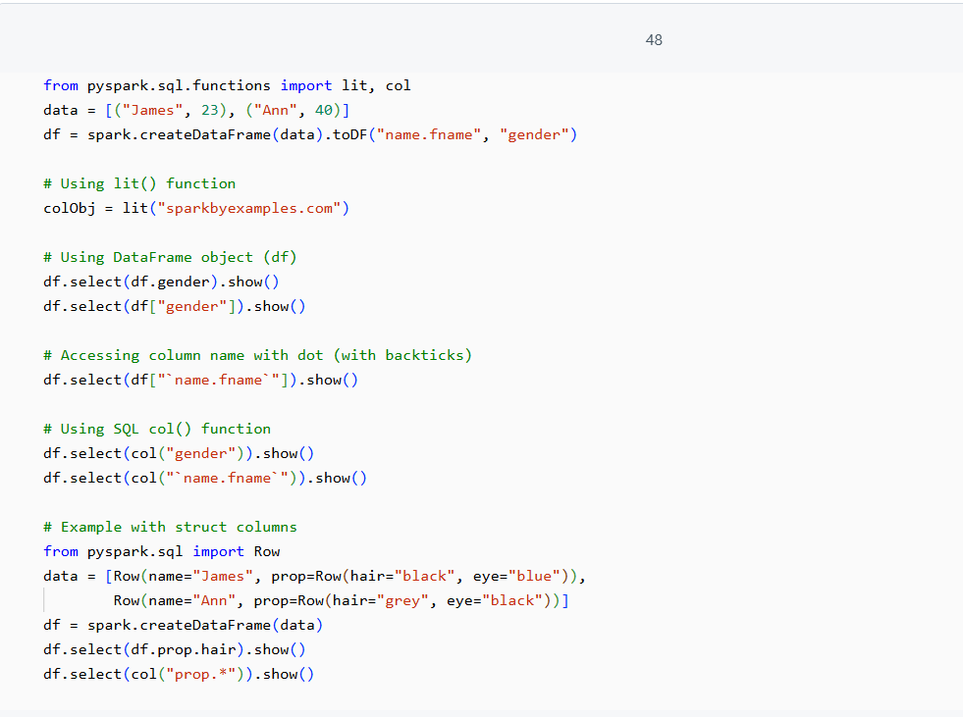

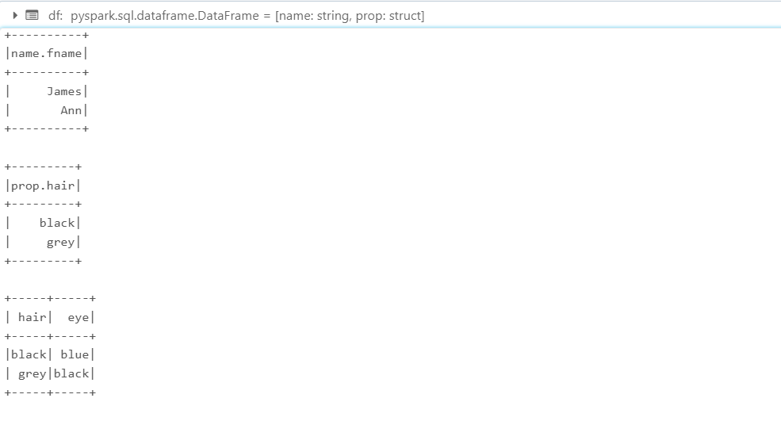
B. PySpark Column Operators
(i). Arithmetic Operations:
Arithmetic operations in PySpark DataFrames allow us to perform basic mathematical calculations between columns. These operations can be done directly on the DataFrame columns using operators like +, -, *, /, and %. PySpark automatically optimizes these operations and computes them in a distributed manner across the cluster.
- Addition (+)
The addition operation allows you to sum the values of two columns.
- Subtraction (-)
The subtraction operation subtracts the values of one column from another.
- Multiplication (*)
The multiplication operation multiplies the values of two columns.
- Division (/)
The division operation divides the values of one column by another.
- Modulo (%)
The modulo operation computes the remainder when dividing the values of one column by another.
(ii).Comparison Operations:
Comparison operations in PySpark DataFrames allow us to compare values between columns and generate boolean results (True or False). These operations are commonly used to filter data or create new columns based on conditions.
- Greater Than (>)
The greater-than operation checks if the value in one column is greater than the value in another column.
- Less Than (<)
The less-than operation checks if the value in one column is less than the value in another column.
- Equal To (==)
The equality operation checks if the value in one column is equal to the value in another column.
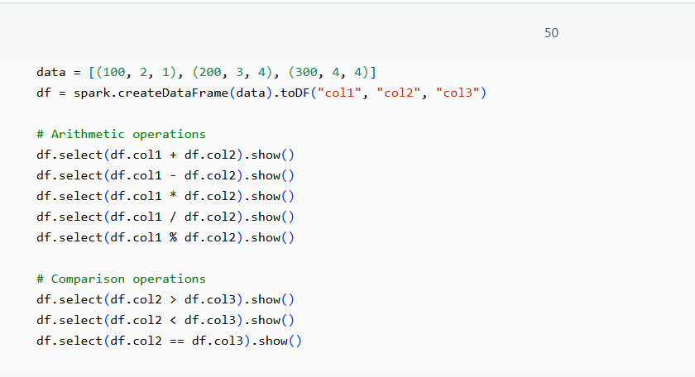
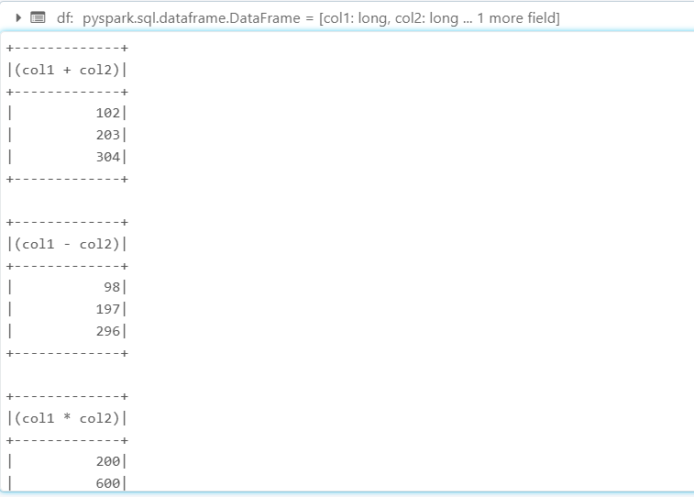
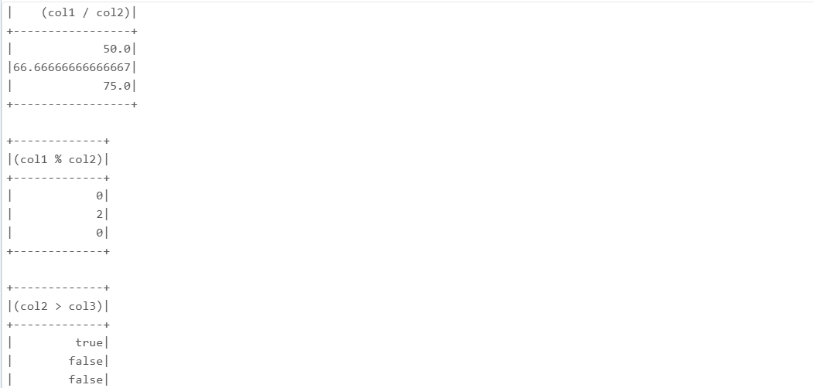
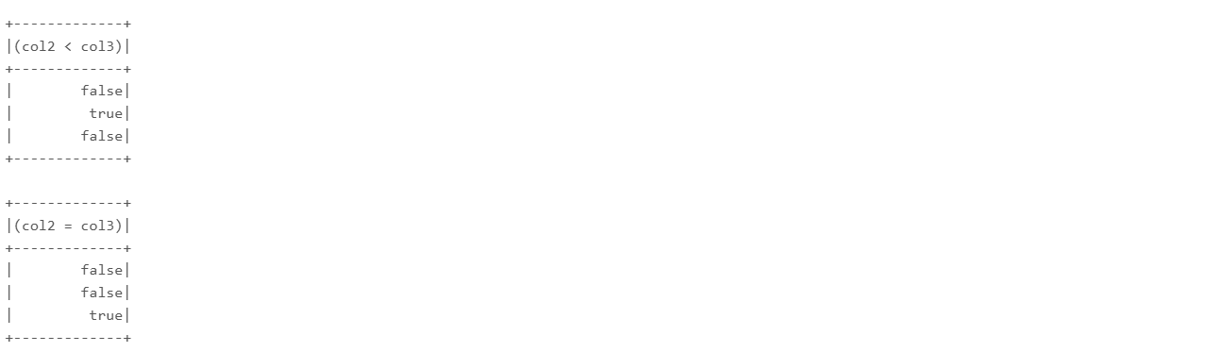
C. PySpark Column Functions
PySpark provides many built-in column functions to alias, sort, cast, filter, and manipulate DataFrame columns efficiently.
Some of the important column functions are as follows:
- alias()
The alias() function is used to rename columns or expressions in a DataFrame. This is particularly useful when you want to give meaningful names to columns resulting from operations.
- asc(), desc()
These functions are used to sort the DataFrame by a column in ascending or descending order.
asc() sorts in ascending order.
desc() sorts in descending order.
- cast()
The cast() function is used to convert the data type of a column. This is often used when performing operations that require specific data types, such as converting a string to an integer.
- between()
The between() function is used to filter rows where the values of a column fall within a specified range, inclusive of the start and end values.
- contains(), startswith(), endswith()
These are string functions used to filter rows based on the presence of specific substrings in string columns.
- contains() checks if a substring is present anywhere in the column.
- startswith() checks if the column starts with the specified substring.
- endswith() checks if the column ends with the specified substring.
- isNull(), isNotNull()
These functions are used to filter rows based on whether the column contains a null value or not.
- like(), rlike()
- like() is used to perform SQL-like pattern matching using wildcards (% for any number of characters and _ for a single character).
- rlike() is used for regular expression matching.
- substr()
The substr() function extracts a substring from a column based on the starting position and length of the substring.
- when(), otherwise()
The when() function is used to implement conditional logic in DataFrame transformations, similar to SQL CASE WHEN. You can combine it with otherwise() to specify the default value when the condition is not met.
- isin()
The isin() function is used to filter rows where the values in a column are present in a list or set of values. This is similar to the SQL IN operator.

